Amber task
Challenge 1
Varied Fluency

52
12
XII
_______

_____________________

XCII
_______
Forty Seven

Challenge Three
Reasoning and Problem Solving

True or False?
Prove it.
a) The Roman numerals IIIIII mean 6.
b) The Roman numerals XL mean 40.
c) The Roman numerals XC mean 90.
Challenge Two
Reasoning and Problem Solving
Match the Arabic numeral to the correct Roman numeral.

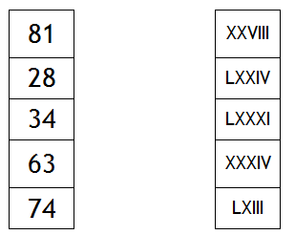

Extra Challenge
Reasoning and Problem Solving

Do you agree with Viktor the Viking?
Why/why not? Give examples.


In the 10 times table, all the numbers have a zero. Therefore, in Roman Numerals all multiples of 10 have an X.

