Amber task 1
Arabic numerals = the numbers we use every day.
Challenge 1
Varied Fluency
Write these calculations out in Roman Numerals and Arabic Numerals.

1. II + V =

2. III + X =

3. VI + L =

Challenge 1
Varied Fluency
Write these calculations out in Roman Numerals and Arabic Numerals.

1. II + V =

2. III + X =

3. VI + L =

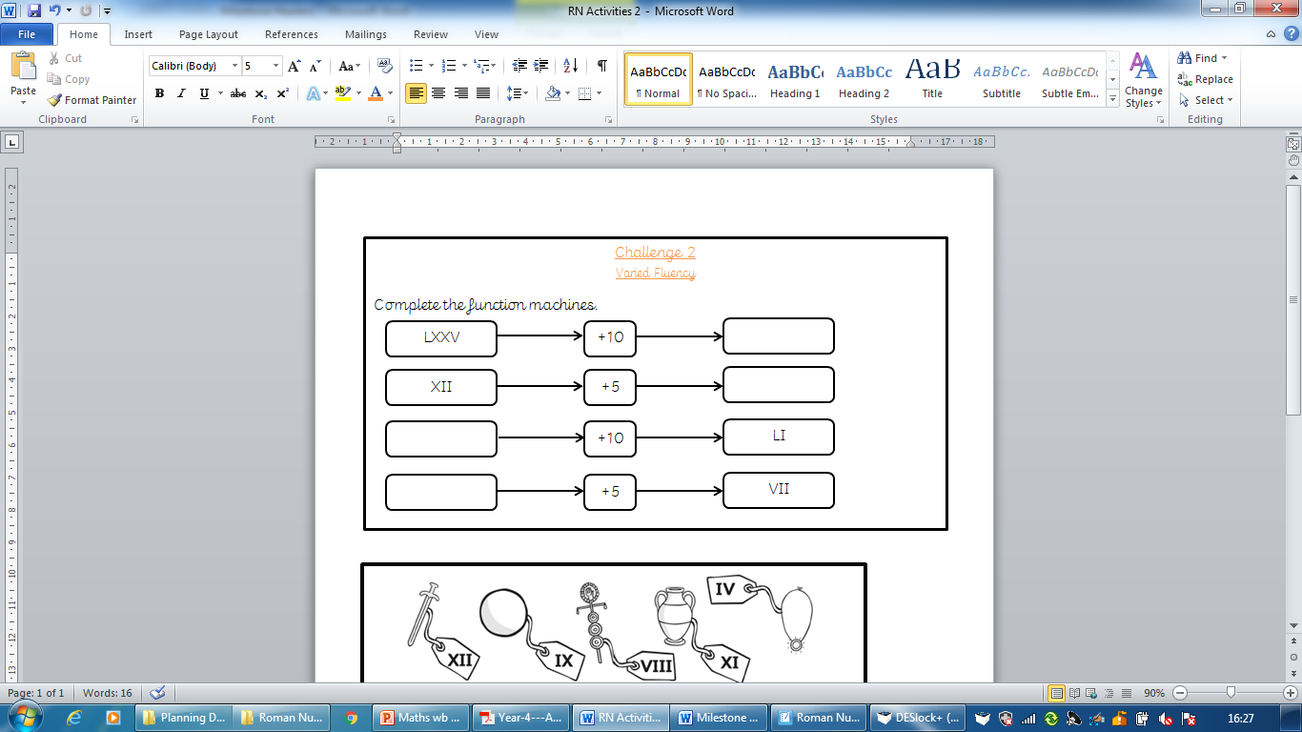
Challenge 2
Varied Fluency
Complete the function machines.

Challenge 2
Varied Fluency
Complete the function machines.

Challenge Three
Reasoning and Problem Solving
Work out the cost of the items on this shopping list for each day of the week.

