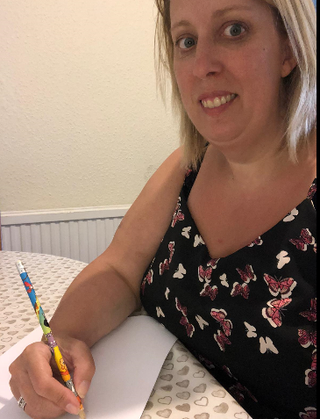
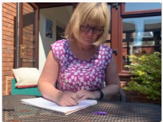
I am a kind of room that has no doors or windows?
I have eyes but I can’t see
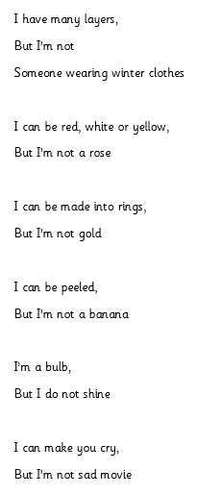
I have skin but I can’t feel anything
I can be sweet but I’m not a piece of candy
I can be baked but I’m not a cake
I can be peeled but I’m not a carrot
What am I?



My name is also a colour.
I’m juicy and sweet, it is said
You will find out my name
If you mix yellow and red!
Great riddles and holding pencil correctly!!!
Look at their pencil holds….. Well done everyone! Look below for a reminder…sing along to the Hokey Cokey tune
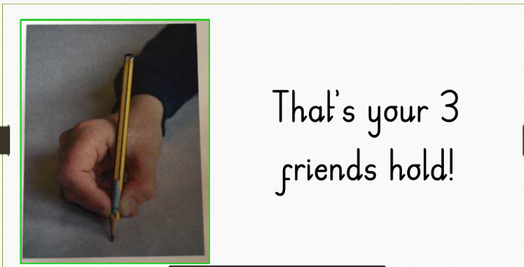
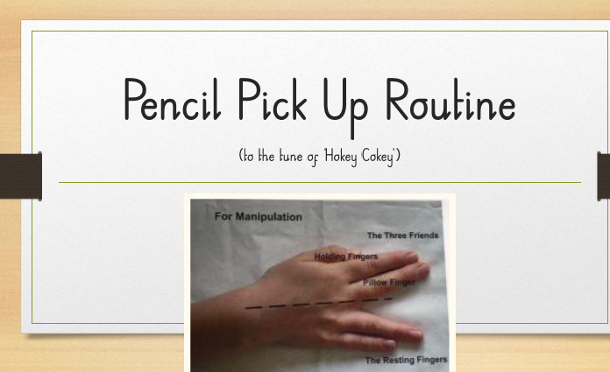
4

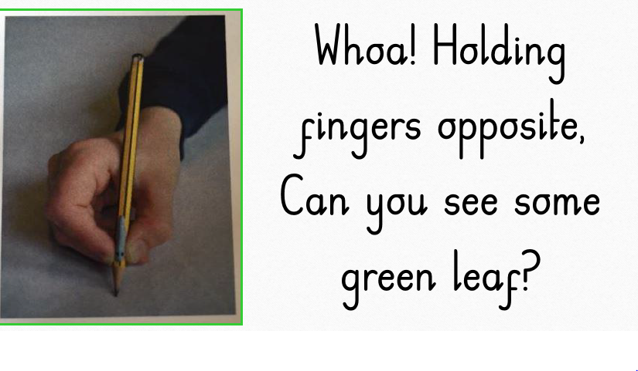
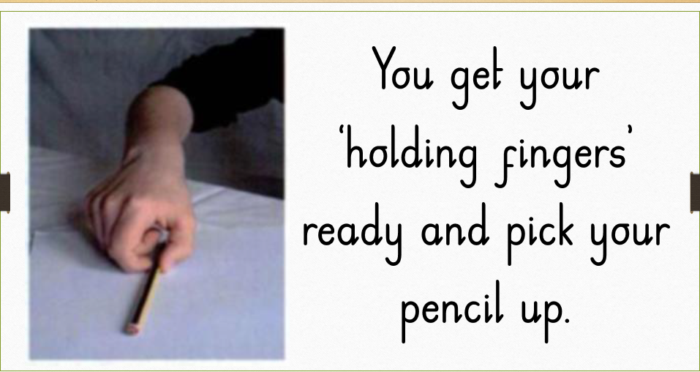
1 5
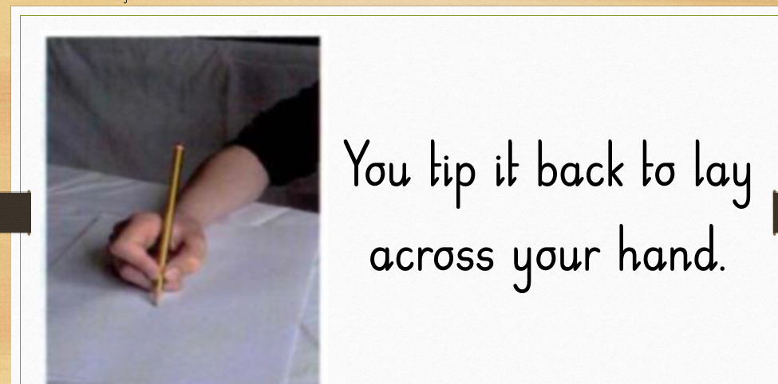
2

6

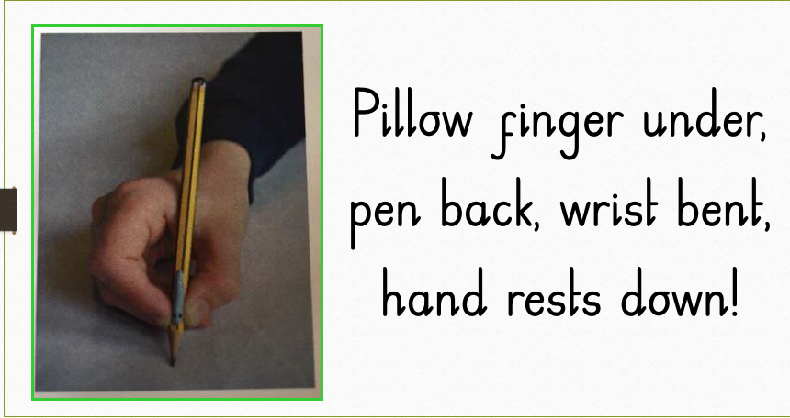

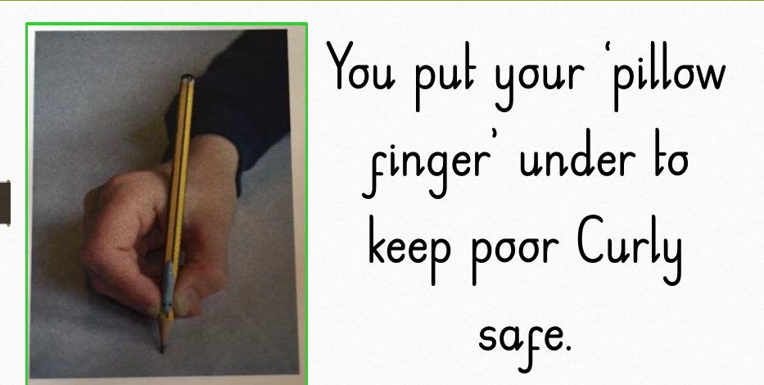
3

