Red task.
If you do not have a printer, you could draw these as bar models using the squares in your book like this:

Remember to make sure you have the correct number of boxes to match the pictures.
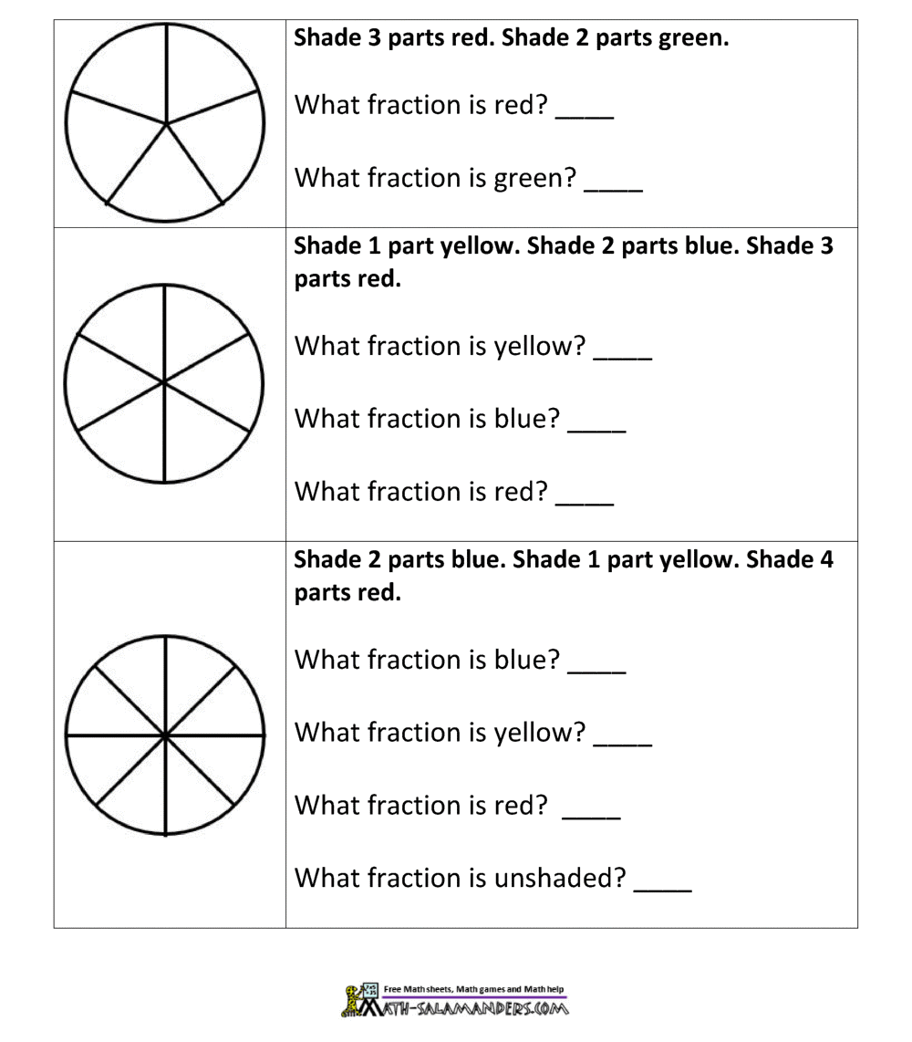

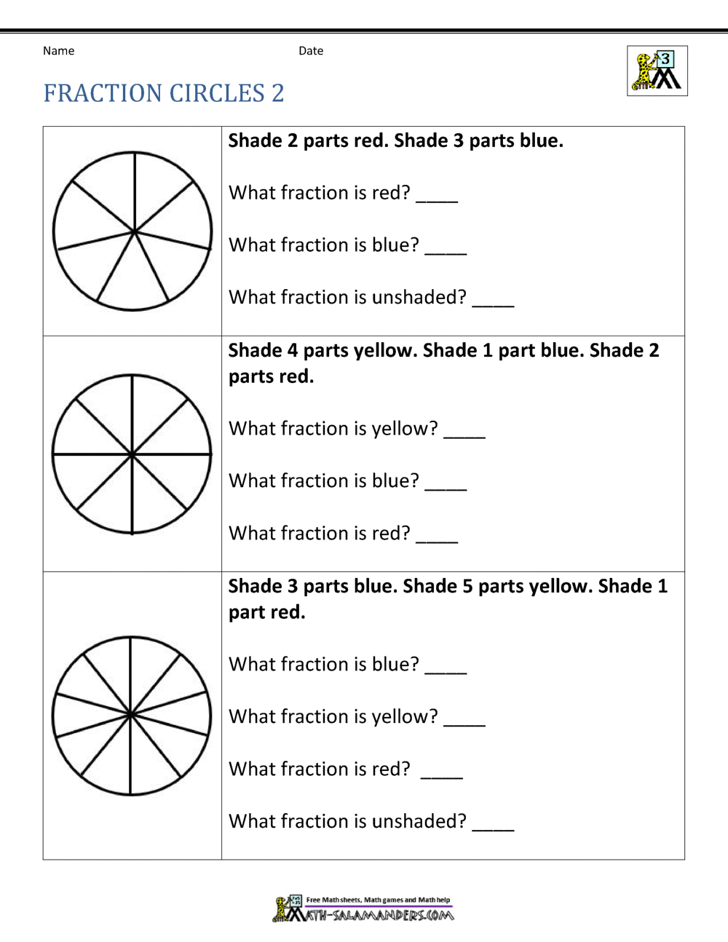

Answers
