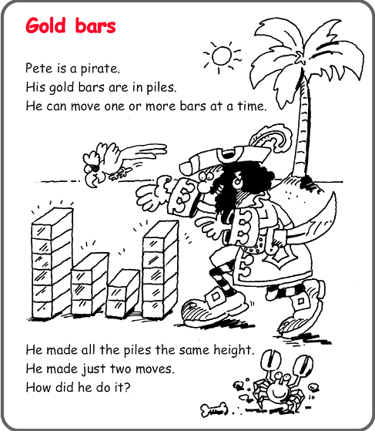

A Friday Brain Teaser
Have a think first.
Count the number of blocks and try to find items at home that represent these blocks.
Books might be useful or food boxes. Try moving them around. Explain how you went about solving the puzzle and how you did it, take a photo if you wish. It would be good to know what you were thinking, maybe try drawing a thought bubble.
Send you answer to your class teacher

