Handwriting

Sit in gorilla pose for 1 minute (you can use a timer or a watch to measure the length of time). Remember to keep that gorilla pose for the full minute!
Get yourself a piece of paper and a pencil. Ensure you have the correct pencil grip (look at the picture below to help you).
Lie in lizard pose and complete the following letters (remember how we taught you form the letters!)

Jumper family letters: h b r n m p
Once these letters have been formed correctly look at the next family: abracadabra family – c o a d g q s
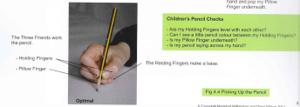

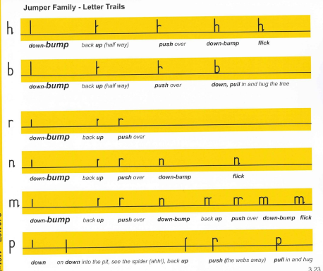

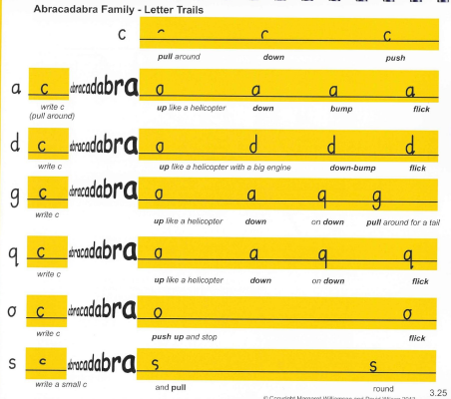

2. Your Warm up today: kneel in meerkat pose for 1 minute
Then put yourself into stone lion position (on hands and knees ensuring back is horizontal, arms/thighs vertical). Stay in this position for 1 minute!

Make sure you have a piece of paper and pencil and lie in lizard pose. Your next family of letters to practise: Window cleaner family – l t i u
Once these letters have been completed and formed correctly introduce the next family: Special Squirter – e
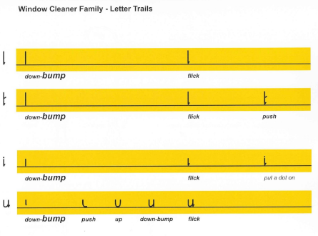

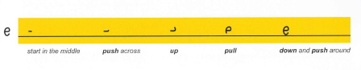

3. Today look at seating position. You should be position in a chair with your back and bottom to the back of the chair and your feet placed firmly on the ground (if your feet don’t reach the ground put a box underneath so that their feet are flat). The chair should be tucked into the table straight and not at an angle. Your back should be upright and straight. Ensure this position is correct before starting the next set of letters. Remember the pencil grip!
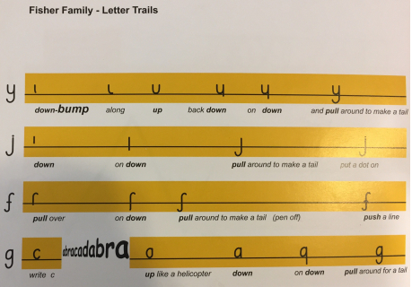

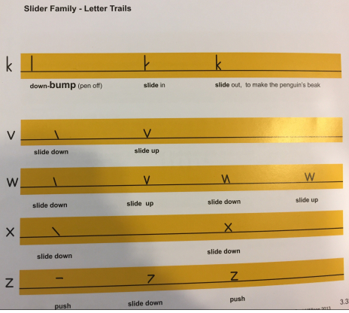

Make sure you practice the strong gorilla, meerkat, lizard and lion pose daily! The stronger your core muscles the better your handwriting will be!! If you feel strong enough to hold the positions for longer than 1 minute then go for it!! Remember to post a picture on our Facebook page of you in these core strengthen positions and let us know how long you can hold them for!

