Amber task
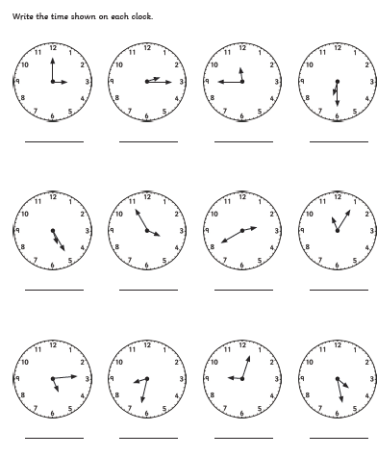
Please write the correct times in words. Don’t forget to use the correct spellings.

